LORNE FOOTBALL NETBALL CLUB INC.

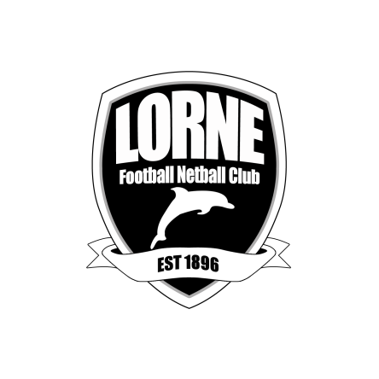
ANNUAL GENERAL MEETING
Friday 1st December 2023

Stribling Reserve Community Centre

FORM OF APPOINTMENT OF PROXY

I
(Name)
Of
(Address)

Being a financial member of Lorne Football Netball Club Inc. Appoint

(Name of proxy holder)
Of

(Address of proxy holder)

Being a financial member of the Lorne Football Netball Club Inc., as my proxy to vote for me on my behalf at the Annual General Meeting to be held on Friday 1st December 2023 and at any adjournment of that meeting.

My proxy is authorised to vote in favour of / against * the following (insert details) *Delete if not applicable

…………………………………………………………………………………………………...
…………………………………………………………………………………………………...
……………………………………………………………………………………………….......

Signed

Date

Please forward to the LNFC Secretary before 29 November 2023
info@lornefnc.com.au

STRIBLING RESERVE, WILLIAM STREET, LORNE
www.lornefnc.com.au

