LORNE FOOTBALL NETBALL CLUB INC.
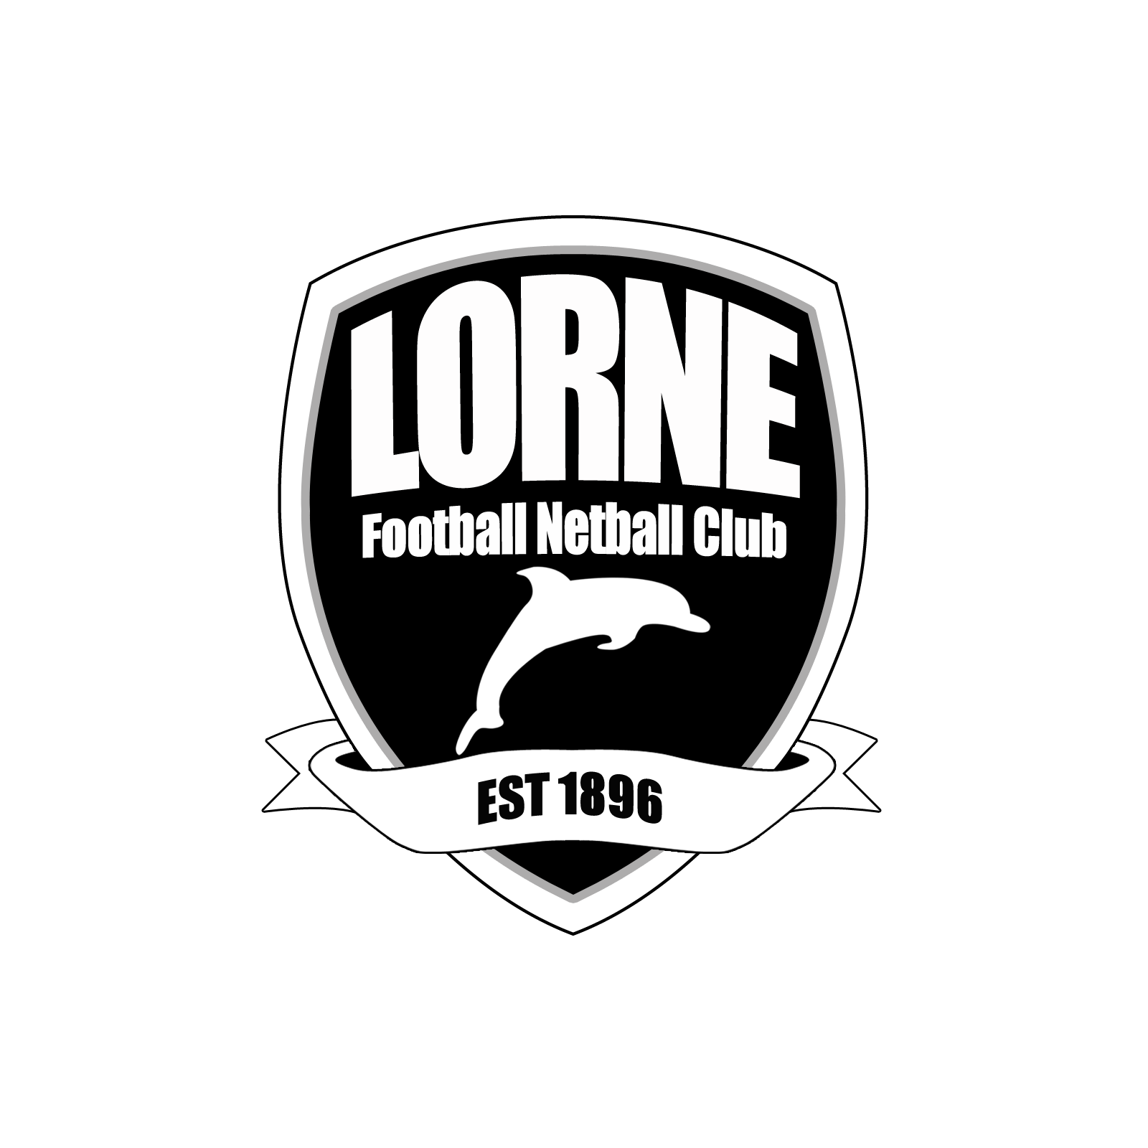

NOMINATION FORM FOR LIFE MEMBERSHIP OF THE LORNE FOOTBALL NETBALL CLUB

I, would like to nominate

For Life Membership of the Lorne Football Club.

I believe

Signed: Proposer

Please forward to the Secretary

PRESIDENT: Carly Enticott VICE PRESIDENT: Miah Atwell

SECRETARY: Ingrid Wilson TREASURER: Richard Coumans

All correspondence
P.O. BOX 140, LORNE 3232

CLUBROOMS - STRIBLING RESERVE, WILLIAM STREET, LORNE

Email info@lornefnc.com.au www.lornefnc.com.au

