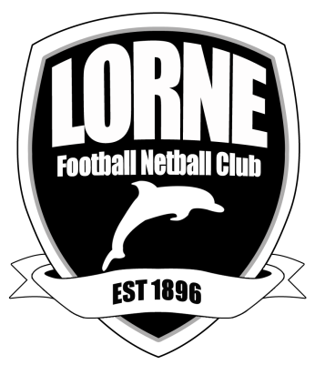
Lorne Football Netball Club Inc.
Annual General Meeting 2024
29 November, 5pm , Stribling Reserve Lorne
Minutes

Present – Carly Enticott, Miah Atwell, Mark Russell, Clive Goldsworthy, Peter Spring, Selena Walding, Tina White, David Worth, Mark Russell, Peter Hunt, Karen Heathcote, Geoff Balderas, John Nelson, Ingrid Wilson

Apologies – Janet Higgins, Richard Coumans, John Agar, Chris Tutungi.

Confirm Minutes of 2023 AGM

Moved Mark Russell Seconded Ingrid Wilson Carried

Business Arising

President’s Report - attached
Carly acknowledged the signing of Ed Curnow elevated the club in terms of success on and off the field.
Thanked Unearthed Collective for their work with running the functions and Thursday Nights.
Thanked the Committee and our sponsors.
Also thanked the Stribling Reserve asset committee – specifically Clive Goldsworthy and Peter Spring.
Thanked Richard Coumans for his work as the Treasurer for 2024.
Very excited about the prospects for 2025.

Moved – Carly Enticott Seconded – Miah Atwell

Treasurer’s report – questions taken on notice as Treasurer not in attendance.
Carly thanked Karen for stepping in to assist Richard, and acknowledged what a big part the Season Launch function played in fund raising.
Committee will work towards signing on new sponsors. Carly thanked Mark Russell for his work in this area.

Moved – Karen Heathcote Seconded – Selena Walding

Senior Football Report – attached
Acknowledged successful year and thanked Ed for his tireless work.

Junior Football Report – attached

Netball Report – attached

That all reports be accepted

Moved - Karen Heathcote Seconded - Ingrid Wilson

Election of office bearers and committee for 2024

One nomination for each position so no election necessary

President – Carly Enticott
Vice President – Miah Atwell
Treasurer – John Nelson
Secretary – Ingrid Wilson
Membership – Janet Higgins
Netball Administrator – Karen Heathcote
Senior football – Mark Russell
Junior Football – Selena Walding
Committee – Johnny Leontiades

Motion – To continue affiliation with CDFNL Inc

Moved Carly Enticott Seconded – Miah Atwell

Appointment of Auditors – Highton and Lorne accountants

Moved - Carly Enticott Seconded – Ingrid Wilson

Life Membership - Three nominations. Two met the criteria within the guidelines.
Ratified 2 nominations
Daniel Kettle – nominated by Belinda Murphy
Wayne Griffiths – nominated by Geoff Balderas and Miah Atwell

Congratulations Daniel and Wayne

Moved – Executive committee Carried

General Business
The committee have decided to move the membership to Member Jungle. To move our membership to an electronic format for easier renewals and man hours of maintaining the data base much less. Initial start up costs worthwhile.

As a result there will be a slight increase in membership costing -

Senior footballer membership and insurance - $210
Senior netballer membership - $110
Junior footballer insurance - $50
Family membership – 2 adults and children including junior players - $150
Social member - $75
Silver member - $45
Coterie - $300
Coterie plus partner - $450

Moved – David Worth seconded – Mark Russell

Meeting closed 5.25pm – thank you to all who attended

Ingrid Wilson
Secretary LFNC

